UNIT 2
Lesson 8 – The place I call home

- 1 Look at the pictures. Read the words.
Pogledaj slike. Pročitaj riječi.

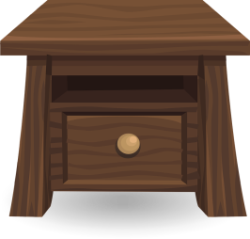
bedside table teddy bear
noćni ormarić medvjedić

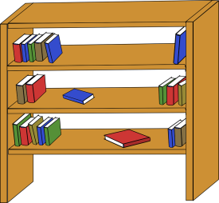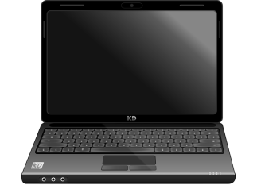
bookcase laptop
polica s knjigama laptop

- 2 Read the text and find out things about Nina's place.
Pročitaj tekst i saznaj nešto o djevojčici Nini.
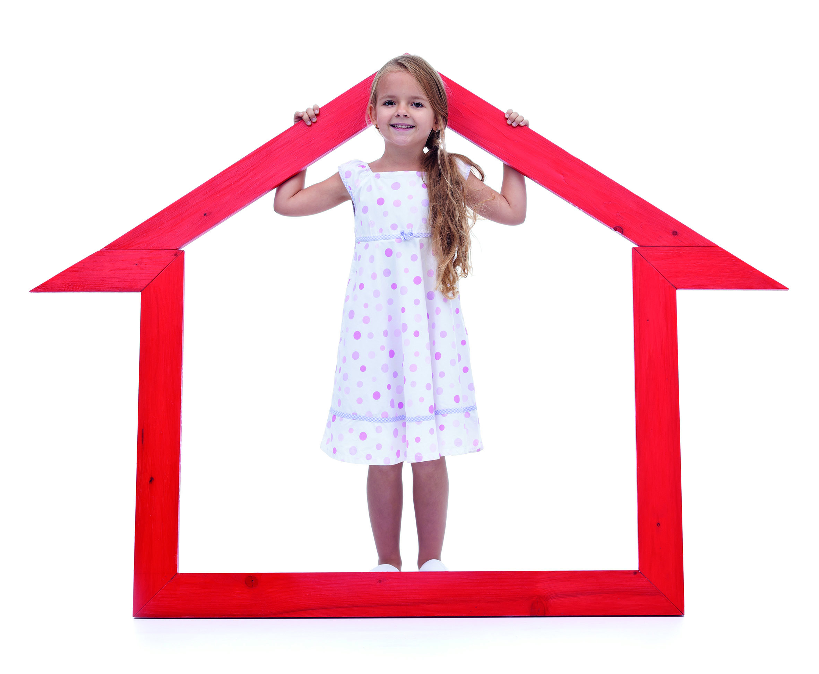

1 Hello! My name is Nina.
Bok! Moje ime je Nina.
I live in a flat with my mum and dad.
Živim u stanu sa svojom mamom i svojim tatom.

2 In our flat there are six (6) rooms.
U našem je stanu šest prostorija.
There are two (2) bedrooms, a living room, a dining room,
a kitchen and a bathroom.
Tamo su dvije spavaće sobe, dnevna soba, blagovaonica,
kuhinja i kupaonica.

3 I sleep in my room.
Ja spavam u svojoj sobi.
It is a small room with green walls.
To je malena soba sa zelenim zidovima.
There is a window opposite the door.
Tamo je prozor koji se nalazi nasuprot vrata.

There is a bed and a bedside table on the left and a big dark brown wardrobe on the right.
S lijeva je noćni ormarić i veliki tamnosmeđi ormar s desna.
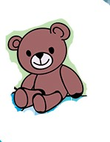

On the bed there is a pillow and
my favourite teddy bear .
Na krevetu je jastuk i moj omiljeni medvjedić.
Next to the window there is a bookcase.
Pored prozora je polica s knjigama.

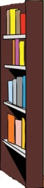

Between the bookcase
and the wardrobe, there is a desk where I do
my homework every day.
Između police s knjigama i ormara je radni stol
na kojem svaki dan pišem zadaću.
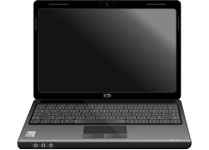

On my desk there is a laptop.
Na mom radnom stolu je laptop.

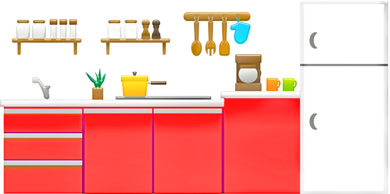
4 My favourite room is the kitchen,
because that’s where my dad makes delicious pancakes
Moja omiljena soba je kuhinja jer moj tata tamo priprema ukusne palačinke.
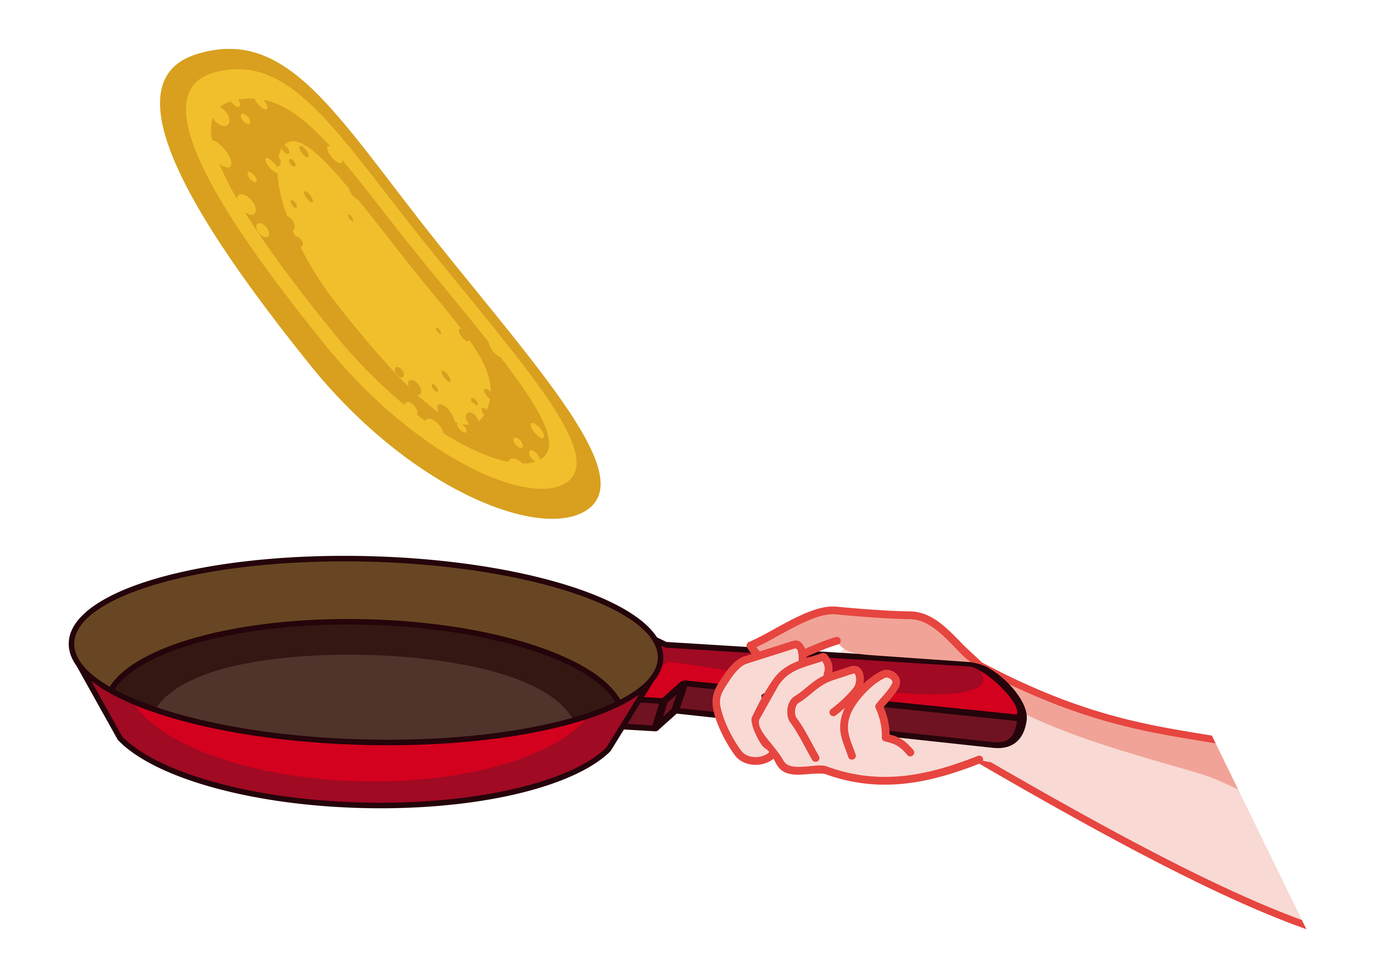

- 3 Read the text in task 2 once more.
Pročitaj tekst o Nini još jednom (zadatak 2).
a) What furniture is in Nina's room?
Koji namještaj se nalazi u Nininoj sobi?
Write the names of different furniture in the empty frames.
Upiši nazive za namještaj u prazne okvire.
b) Tick the right picture of Nina's room.
Označi kvačicom sliku Ninine sobe.

door

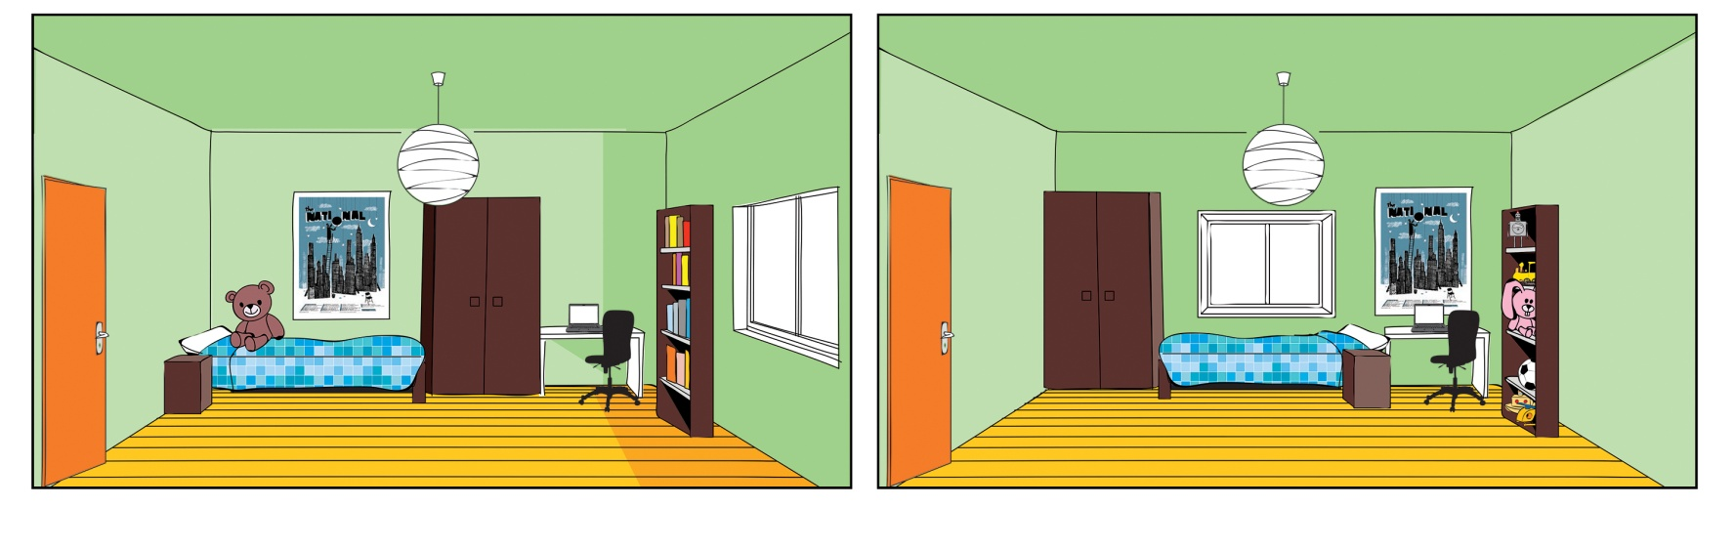

- 4 Write about yourself. Piši o sebi
a) Answer the questions. Odgovori na pitanja.

Who do you live with?  S kim živiš?  Circle the people who you live with.  Zaokruži one s kojima živiš. | mum dad  brother sister  grandpa grandma
Do you live in a house or a flat?  Živiš li u kući ili stanu?  Underline the correct word.  Podcrtaj točnu riječ. | I live in a house / a flat.
How many rooms are there?
Koliko je tamo soba?

Write the number.
Upiši broj u kućicu.
Which rooms are there?  Koje su sve sobe tamo?  Circle the rooms.  Zaokruži sobe. | bedroom  bathroom  dinning room  living room  kitchen
Where do you sleep?  Gdje ti spavaš?  Underline the correct sentence.  Podcrtaj točnu rečenicu. | I share my room with somebody.  I sleep alone in my room.
What is in that room?  Circle the items in your room.  Zaokruži stvari koje su u tvojoj sobi. | table bed  window door  pillow walls  laptop  bedside table (noćni ormarić)  bookcase (polica s knjigama)  teddy bear (medvjedić)
What is your favourite room?  Koja ti je omiljena soba?  Why?  Zašto? | _______________________  _______________________  _______________________  _______________________  _______________________  _______________________

b) Now, complete the sentences about yourself.
Sada dovrši rečenice o sebi.

1 I live with _______________________________________ .
2 I live in _________________________________________ .
3 There are __________________________ rooms there.
4 The rooms are :__________________________________ .
5 I _____________________________________ my room.
(I share / I don't share)
6 In my room there is________________________________ _________________________________________________ .
7 My favourite room is ______________________________ .

PROJECT TIME
Vrijeme je za projekt.

- 5 Cut out the pairs in half. Izreži parove po sredini.
Mix them up. Pomiješaj dijelove.
Match them together again. Opet ih spari.
Glue them in your notebook. Zalijepi ih tako u bilježnicu.
malen
small
beautiful
lijep

safe
siguran
unsafe
nesiguran
ugly
ružan

comfortable
udoban

neudobno
uncomfortable

big
velik

- 6 Complete the table with the opposites.
Dovrši tablicu sa suprotnim riječima.

Find help in task 5.
Potraži rješenja u 5. zadatku.

beautiful | ugly
small
safe
 | uncomfortable

- 7 Look at the pictures of different homes (1-6).
Pogledaj slike različitih kuća na slikama od 1 do 6.
a) Write the words that describe them on the empty lines.
Upiši riječi koje ih opisuju na prazne crte.
Use the words in the frame.
Upotrijebi riječi iz okvira.

beautiful small ugly
comfortable unsafe uncomfortable
safe

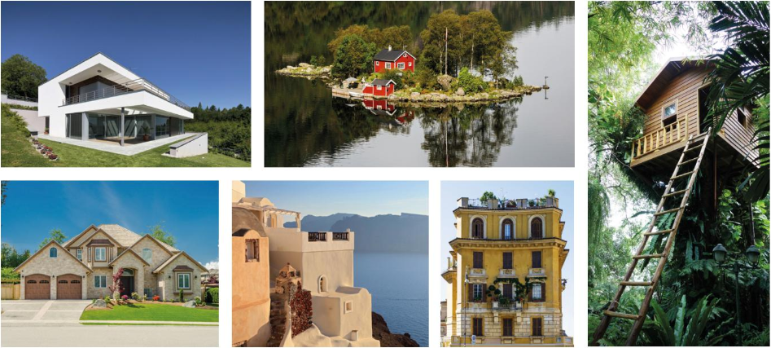
3
2
1
6
5
4

1______________________________________
2______________________________________
3______________________________________
4______________________________________
5______________________________________
6______________________________________

b) Which home do you like the best? Why?
Koja ti se kuća sviđa? Zašto?
Talk to your classmate.
Povedi razgovor sa svojim prijateljem iz klupe.

- 8 Imagine that you are buying a new house.
Zamisli da kupuješ kuću.
Think about what is important for you.
Koje bi ti stvari bile važne pri kupnji kuće?
Listen to you teacher/classmate read the sentences.
Poslušaj učitelja / prijatelja iz razreda kako čita rečenicu po rečenicu.
Tick the ones that are important to you.
Stavi kvačicu pored onih koje su tebi važne kod kupnje kuće.

1 It's easy to clean.
Jednostavna je za održavanje / čišćenje.
2 It's near a school.
Blizu je škole.
3 It's near other children.
Blizu je kuća druge djece.
4 It's near a supermarket.
Blizu je trgovine.
5 It's near a park.
Blizu je parka.
6 It has a big garden.
Ima veliki vrt.
7 It's big.
Velika je.
8 It's quiet.
Susjedstvo je mirno.
9 There aren't many neighbours.
Nema puno susjeda u blizini.

- 9 Find the picture of your perfect home online.
Pronađi sliku svog savršenog doma na internetu.
Glue it in the empty frame.
Zalijepi ju u prazan okvir.

MY PERFECT HOME
Moj savršen dom

- 10 Describe your perfect home.
Opiši svoj savršeni dom.
Complete the sentences about your perfect home.
Dovrši rečenice o svom savršenom domu.
1 My perfect house is _______________________________ .
big/small

2 There are __________________________ rooms there.
(upiši broj soba)
3 The rooms are :__________________________________ .
(imenuj sobe u domu)
4 In my room there is________________________________ _________________________________________________ .
(upiši što se od namještaja nalazi u tvojoj sobi)
5 My favourite room is / rooms are_____________________
_________________________________________________ .
6 I spend my free time _____________________________ .
(upiši u kojoj sobi provodiš slobodno vrijeme)

